### **INTERACTIVE LEARNING PLATFORM**

|  |  |
| --- | --- |
| **AKASH S****2022503041****[akashkumaran15@gmail.com](mailto:akashkumaran15@gmail.com)** | **YUGASH D****2022503039****[dyugash@gmail.com](mailto:dyugash@gmail.com)** |

### **System Requirements Specification (SRS) Document for**

### **Interactive Learning Platform**

#### **1. Introduction**

##### **1.1 Purpose**

##### This SRS document is about the requirements of the Interactive Learning Desktop platform meant for self-directed learning. This is done via short sessions on a daily basis. The features includes including the selection of adequate courses, interactive content, tracking of progress, sending of notifications, quizzes, and gamification. It is implemented in Java language for both frontend (Java Swing) and backend (Java) where MySQL serves as the DBMS for the application data.

##### **1.2 Scope**

##### The platform is intended to be more interactive in terms of course provision, management, lessons, quizzes, and tracking of users’ progress. These features support learning through short bursts on a daily basis and apply gamification techniques like streaks and stars to encourage user participation. Leader boards and notifications help further the cause of user capture. The system will be developed as a desktop application using Java technologies with MySQL for data handling.

##### **1.3 Definitions, Acronyms, and Abbreviations**

* **SRS**: System Requirements Specification
* **GUI**: Graphical User Interface
* **DBMS**: Database Management System
* **JDBC**: Java Database Connectivity
* **NFR**: Non-Functional Requirements

##### **1.4 References**

* **Software Engineering: A Practitioner's Approach** by Roger Pressman
* **Java Swing Documentation** by Oracle

#### **2. Overall Description**

##### **2.1 Product Perspective**

##### The Interactive Learning Platform is a desktop application that has been planned for purposes of enhancing the learning process. This system also handles user registration, course registration, interactive lessons, course lessons and progress tracking synergized incorporation of game mechanics. Data storage and retrieval in the Java application is done against the MySQL database ensuring fluidity and connectivity for the user application.

##### **2.2 Product Features**

* **User Registration and Login**: Enables user registration and secure login with password encryption.
* **Course Selection**: Allows users to select and manage courses, set daily learning times, and track streaks.
* **Interactive Content**: Provides drag-and-drop activities, quizzes, and lesson-based content.
* **Progress Tracking**: Displays user progress, streaks, stars earned, and a leaderboard for comparison.
* **Lesson Management**: Allows skipping or bookmarking lessons and managing learning schedules through a calendar.

##### **2.3 User Classes and Characteristics**

* **Learners**: Users who enroll in courses and interact with the platform's features to track their learning progress.
* **Administrators**: Users who manage course content, user accounts, and monitor system performance.

##### **2.4 Operating Environment**

The system will run on desktop environments that support Java and MySQL. It will require an internet connection for updates and data synchronization.

##### **2.5 Design and Implementation Constraints**

* The system must use Java Swing for the frontend and Java for backend logic.
* MySQL will be the database for storing user data, course content, and progress tracking.
* The system must ensure security and data integrity during data transmission and storage.

##### **2.6 Assumptions and Dependencies**

* Assumes the user has a Java runtime environment installed.
* Depends on the availability of the MySQL server for database operations.
* Assumes internet connectivity for receiving notifications and syncing data.

#### **3. Specific Requirements**

##### **3.1 Functional Requirements**

 ●     **FR1**: It should be possible to register with the system using the name, email, and password.

 ●     **FR2**: The system must be able to accommodate login with a user’s email and password.

 ●     **FR3**: The system shall encrypt the password before saving it in the MySQL database.

 ●     **FR4**: Based on the user preferences the system shall provide a list of learning domains.

 ●     **FR5**: The system shall enable the users to search in the list of courses and choose the ones that are of interest.

 ●     **FR6**: The system shall allow content that is more engaging quizzes.

 ●     **FR7**: The system shall include the leader board that will allow users to compare their progress.

##### **3.2 Performance Requirements**

 ●   The system should be capable of displaying the home page and the related personalized content in not more than two seconds.

 ●   The system shall effectively manage the database queries and reduce the amount of time taken to obtain data.

##### **3.3 Non-Functional Requirements**

 ●   **Reliability**: The system shall maintain 99. 99% up time and synchronize the data between Java application and MySQL.

 ●   **Maintainability**: The system code shall be modular, well-documented and should be maintained with respect to the best practices in case of future modification.

##### **3.4 System Attributes**

 ●   **Scalability**: The system shall be expandable to accommodate more users and bigger sets of data as the platform develops.

 ●   **Portability**: The system shall run in various operating systems that are friendly with Java and MySQL.

#### 

#### 

#### 

#### **4. System Architecture**

##### **4.1 Overview**

The system is designed with a three-tier architecture:

1. **Presentation Layer:** Java Swing will be used for the GUI to handle user interactions and display course content and progress tracking.
2. **Application Layer:** Java will manage business logic, user authentication, and course management, interacting with MySQL through Java JDBC.
3. **Data Layer:** MySQL will store user data, course content, progress tracking, with Java JDBC handling the database connections.

##### **4.2 System Modules**

* **User Management Module**: Handles user registration, login, and profile management using Java.
* **Course Management Module**: Manages course creation, updates, and display to users.
* **Progress Tracking Module**: Tracks user progress, streaks, and stars, storing this data in MySQL.
* **Interactive Content Module**: Supports interactive features like drag-and-drop and quizzes.

#### **5. Assumptions and Dependencies**

* The system assumes internet connectivity for users.
* The system depends on the Java runtime environment and MySQL database server.

#### **6.Glossary**

#### **JDBC:**Java Database Connectivity is an API that enables Java applications to interact with databases.

**USE CASE FOR INTERACTIVE LEARNING PLATFORM**

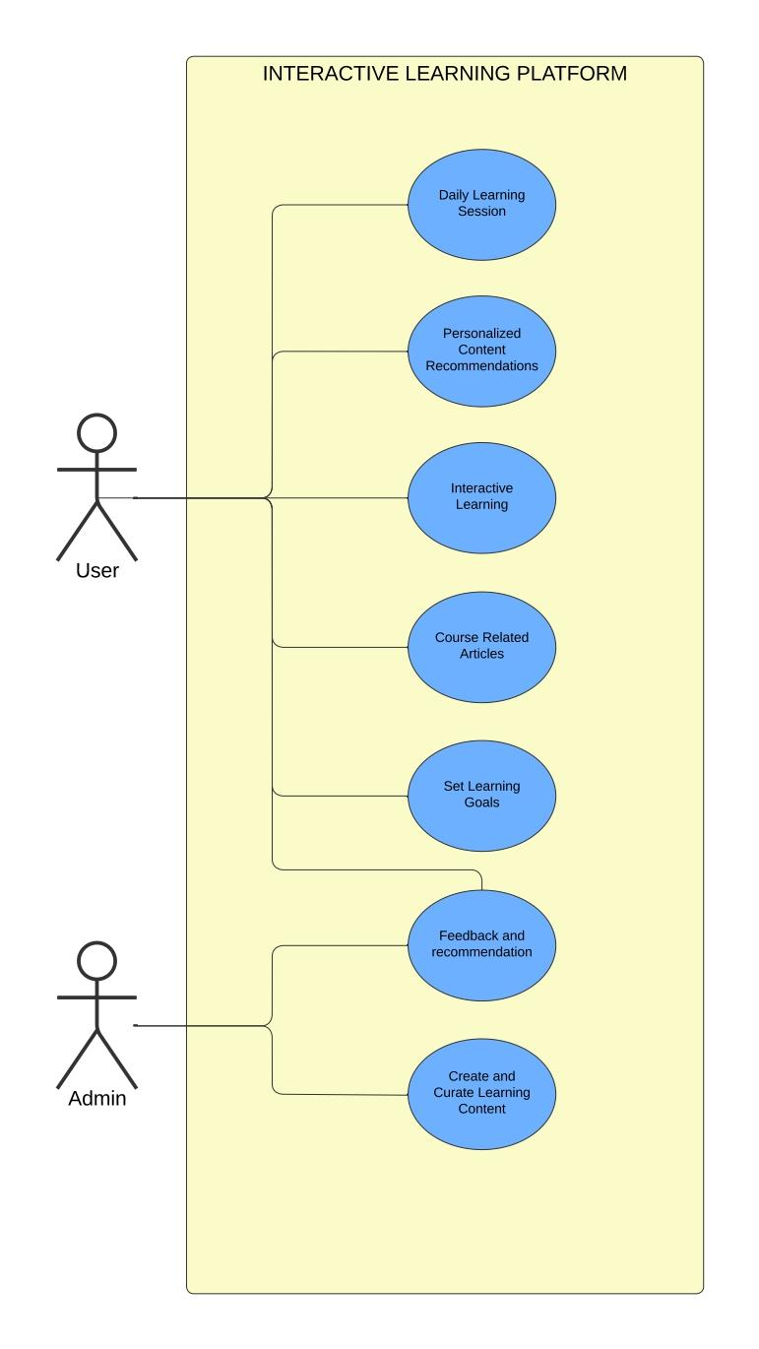

## CLASS DIAGRAM

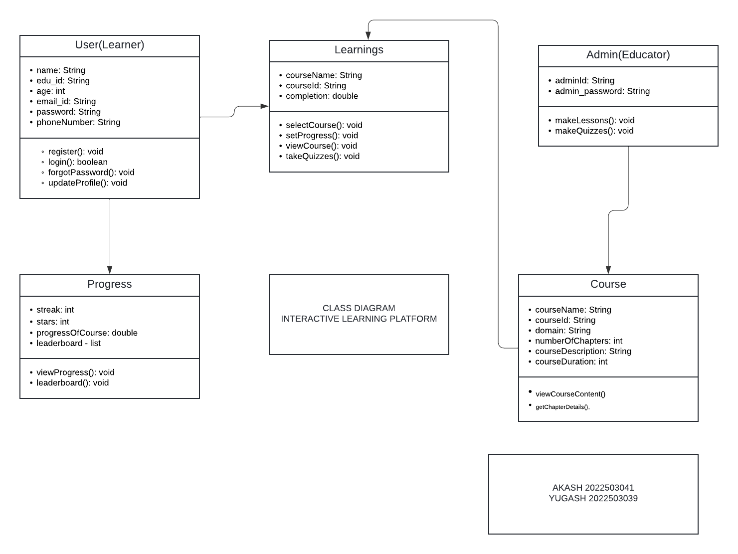

# 

# CRC Table

|  |  |  |
| --- | --- | --- |
| **Class** | **Responsibilities** | **Collaborators** |
| **User (Learner)** | - Register a new user  - Login/Logout the user  - Update user profile | - Learnings  - Progress  - Course |
| **Learnings** | - Select and enroll in courses  - Set course progress  - View enrolled courses  - Take quizzes | - Course  - User |
| **Progress** | - Track user progress  - Calculate and update course progress | - Learnings  - User |
| **Course** | - Provide course content  - Manage course details (chapters, duration)  - Display course content and chapter details | - Learnings  - User |

### 

### **1. User Management Module**

|  |  |  |  |
| --- | --- | --- | --- |
| **Class Name** | **Attributes** | **Methods (Responsibilities)** | **Collaborators** |
| User (Learner) | name: String, edu_id: String, age: int, email_id: String, password: String, phoneNumber: String | register(), login(), forgotPassword(), updateProfile() | Learnings, Progress, Course |

### **2. Course Management Module**

|  |  |  |  |
| --- | --- | --- | --- |
| **Class Name** | **Attributes** | **Methods (Responsibilities)** | **Collaborators** |
| Course | courseName: String, courseId: String, domain: String, numberOfChapters: int, courseDescription: String, courseDuration: int | viewCourseContent(), getChapterDetails() | Learnings, Admin |
| Learnings | courseName: String, courseId: String, completion: double | selectCourse(), setProgress(), viewCourse(), takeQuizzes() | Course, Quiz, User |

### 

### **3. Progress Tracking Module**

|  |  |  |  |
| --- | --- | --- | --- |
| **Class Name** | **Attributes** | **Methods (Responsibilities)** | **Collaborators** |
| Progress | streak: int, stars: int, progressOfCourse: double | viewProgress(), leaderboard() | Learnings, User |

### 

**CLASS CODE STRUCTURE**

Connect_DB

import java.sql.*;

import java.io.BufferedReader;

import java.io.InputStreamReader;

import java.util.Scanner;

public class Connect_DB {

public static Connection getConnection() throws SQLException {

String url = "jdbc:mysql://localhost:3306/OOAD_project";

String userName = "root";

String password = "root";

return DriverManager.*getConnection*(url, userName, password);

}

public static void viewCourses() throws Exception {

String query = "SELECT * FROM Course";

try (Connection con = *getConnection*();

Statement st = con.createStatement();

ResultSet rs = st.executeQuery(query)) {

while (rs.next()) {

System.*out*.println(

"\nCourse Name: " + rs.getString(2) +

"\nDomain: " + rs.getString(3) +

"\nNumber of Chapters: " + rs.getInt(4) +

"\nCourse Description: " + rs.getString(5) + "\n"

);

}

}

}

public static void getChapterDetails() throws Exception {

BufferedReader reader = new BufferedReader(new InputStreamReader(System.*in*));

String query = "SELECT courseName, numberOfChapters FROM Course WHERE courseName = ?";

try (Connection con = *getConnection*(); PreparedStatement pst = con.prepareStatement(query)) {

System.*out*.println("Enter the Course Name:");

String course = reader.readLine();

pst.setString(1, course);

ResultSet rs = pst.executeQuery();

if (rs.next()) {

String courseName = rs.getString("courseName");

int chapters = rs.getInt("numberOfChapters");

System.*out*.println("Course: " + courseName + " has " + chapters + " chapters.");

} else {

System.*out*.println("No details found for the course: " + course);

}

}

}

// Method to insert a new course into the Course table

public static void insertCourse() throws Exception {

Scanner sc = new Scanner(System.*in*);

// Prompt user for course details

System.*out*.println("Enter the Course Details (courseId/courseName/domain/numberOfChapters/courseDescription):");

String courseId = sc.next();

sc.nextLine();

String courseName = sc.nextLine();

String domain = sc.nextLine();

int numberOfChapters = sc.nextInt();

sc.nextLine();

String courseDescription = sc.nextLine();

// Query with placeholders for inserting into Course table

String query = "INSERT INTO Course (courseId, courseName, domain, numberOfChapters, courseDescription) VALUES (?, ?, ?, ?, ?)";

try (Connection con = *getConnection*(); PreparedStatement pst = con.prepareStatement(query)) {

pst.setString(1, courseId);

pst.setString(2, courseName);

pst.setString(3, domain);

pst.setInt(4, numberOfChapters);

pst.setString(5, courseDescription);

int rows = pst.executeUpdate();

System.*out*.println(rows + " row inserted.");

}

}

public static void main(String[] args) {

Scanner sc = new Scanner(System.*in*);

try {

while (true) {

System.*out*.println("\nSelect an option:");

System.*out*.println("1. View Courses");

System.*out*.println("2. Get Chapter Details");

System.*out*.println("3. Insert a New Course");

System.*out*.println("4. Exit");

int choice = sc.nextInt();

sc.nextLine(); // Consume newline

switch (choice) {

case 1:

*viewCourses*();

break;

case 2:

*getChapterDetails*();

break;

case 3:

*insertCourse*();

break;

case 4:

System.*out*.println("Exiting...");

return;

default:

System.*out*.println("Invalid option. Please try again.");

}

}

} catch (Exception e) {

e.printStackTrace();

}

}

}

Courses

import java.sql.Connection;

import java.sql.ResultSet;

import java.sql.Statement;

import java.util.List;

public class Course {

private String courseName;

private String courseId;

private String domain;

private int numberOfChapters;

private String courseDescription;

public Course(String courseName, String courseId, String domain, int numberOfChapters, String courseDescription, int courseDuration, List<String> prerequisites) {

this.courseName = courseName;

this.courseId = courseId;

this.domain = domain;

this.numberOfChapters = numberOfChapters;

this.courseDescription = courseDescription;

}

}

Learnings

public class Learnings {

private String courseName;

private String courseId;

private double completion;

public Learnings(String courseName, String courseId) {

this.courseName = courseName;

this.courseId = courseId;

this.completion = 0.0; // Default completion

}

public void selectCourse() {

// Course selection logic

}

public void setProgress(double progress) {

this.completion = progress;

}

public void viewCourse() {

// View course logic

}

public void takeQuizzes() {

// Take quiz logic

}

// Getters and setters

}

Progress

import java.util.List;

import java.util.ArrayList;

public class Progress {

private int streak;

private int stars;

private double progressOfCourse;

private List<String> leaderboard;

public Progress() {

this.streak = 0;

this.stars = 0;

this.progressOfCourse = 0.0;

this.leaderboard = new ArrayList<>();

}

// Logic for viewing progress

public void viewProgress() {

System.*out*.println("Current Progress: " + progressOfCourse + "%");

System.*out*.println("Streak: " + streak + ", Stars: " + stars);

}

// Logic for showing leaderboard

public void leaderboard() {

System.*out*.println("Leaderboard: ");

for (String user : leaderboard) {

System.*out*.println(user);

}

}

// Method to add users to the leaderboard

public void addUserToLeaderboard(String user) {

leaderboard.add(user);

System.*out*.println("User " + user + " added to leaderboard.");

}

// Logic to update progress

public void updateProgress(double progress) {

if (progress >= 0 && progress <= 100) {

this.progressOfCourse = progress;

System.*out*.println("Course progress updated to: " + progressOfCourse + "%");

}

}

}

User

public class User {

private String name;

private String edu_id;

private int age;

private String email_id;

private String password;

private String phoneNumber;

public User(String name, String edu_id, int age, String email_id, String password, String phoneNumber) {

this.name = name;

this.edu_id = edu_id;

this.age = age;

this.email_id = email_id;

this.password = password;

this.phoneNumber = phoneNumber;

}

public void register() {

// Registration logic here

}

public boolean login() {

// Login logic here

return true; // return success/failure

}

public void forgotPassword() {

// Password reset logic here

}

public void updateProfile() {

// Profile update logic here

}

// Getters and setters if needed for private attributes

}

Admin

public class User {

private String name;

private String edu_id;

private int age;

private String email_id;

private String password;

private String phoneNumber;

public User(String name, String edu_id, int age, String email_id, String password, String phoneNumber) {

this.name = name;

this.edu_id = edu_id;

this.age = age;

this.email_id = email_id;

this.password = password;

this.phoneNumber = phoneNumber;

}

public void register() {

// Registration logic here

}

public boolean login() {

// Login logic here

return true; // return success/failure

}

public void forgotPassword() {

// Password reset logic here

}

public void updateProfile() {

// Profile update logic here

}

// Getters and setters if needed for private attributes

}

OUTPUT:

viewCourse():

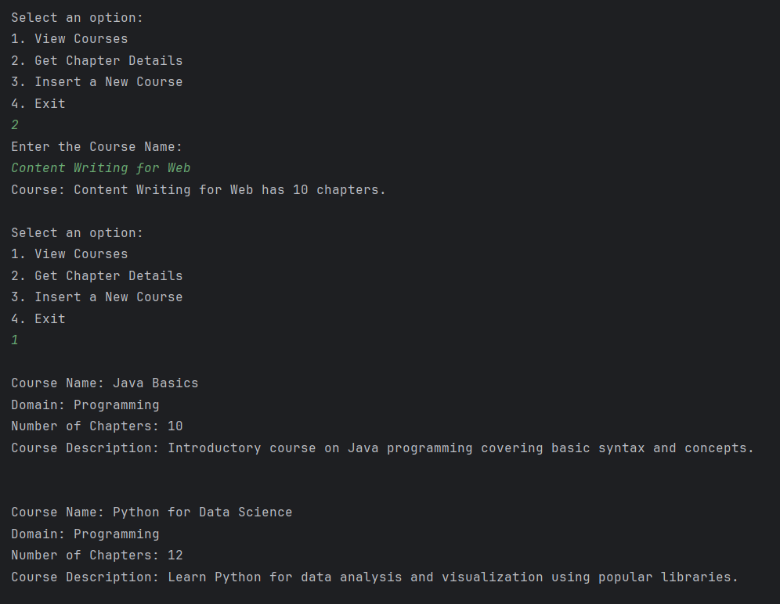

getChapters():

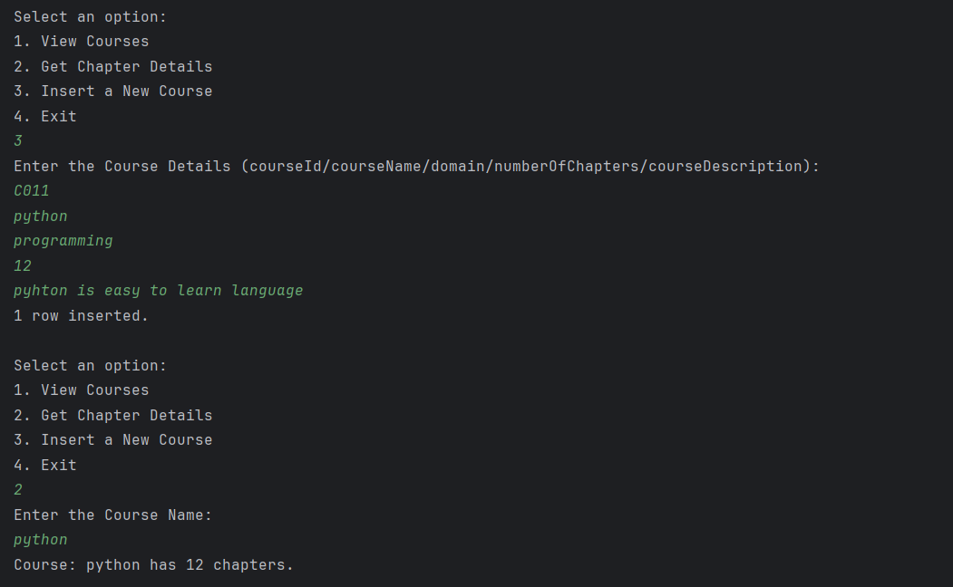

CLASS DIAGRAM IN UML

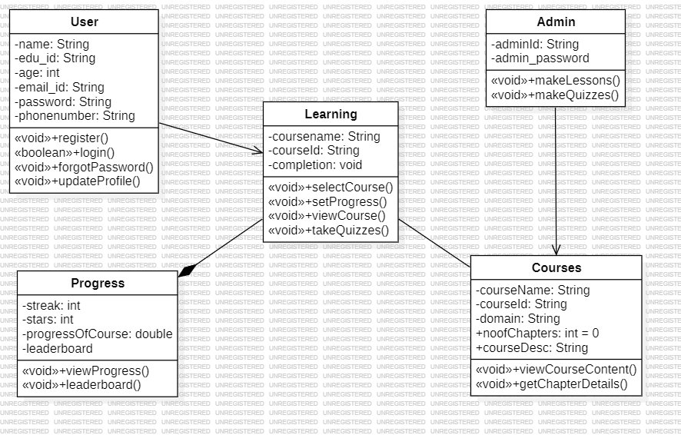

**DATA FLOW DIAGRAM**

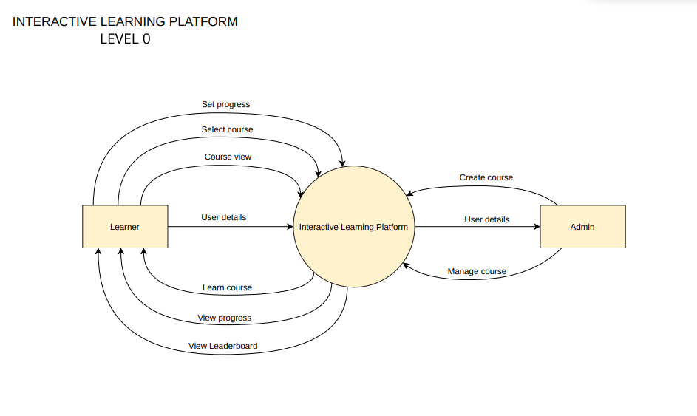

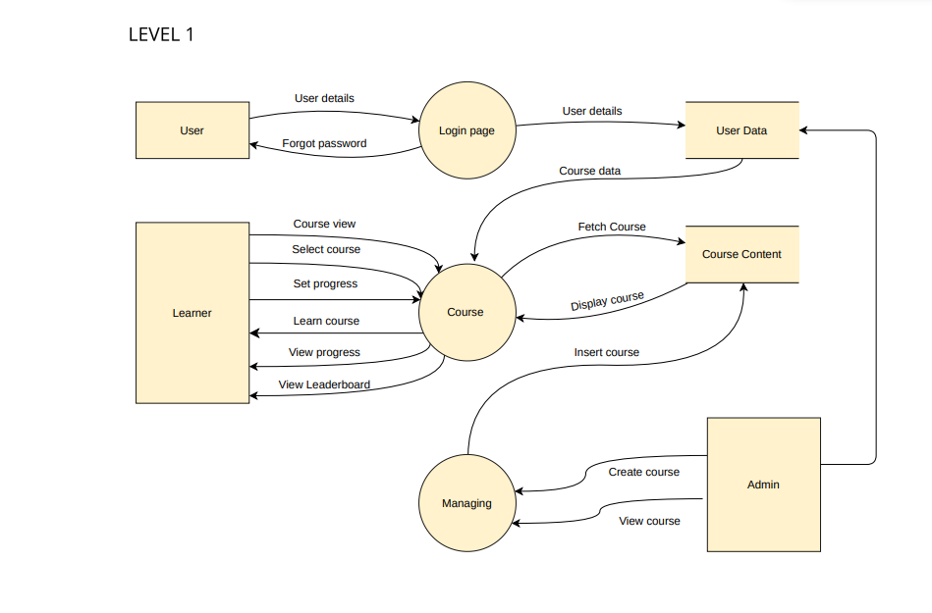

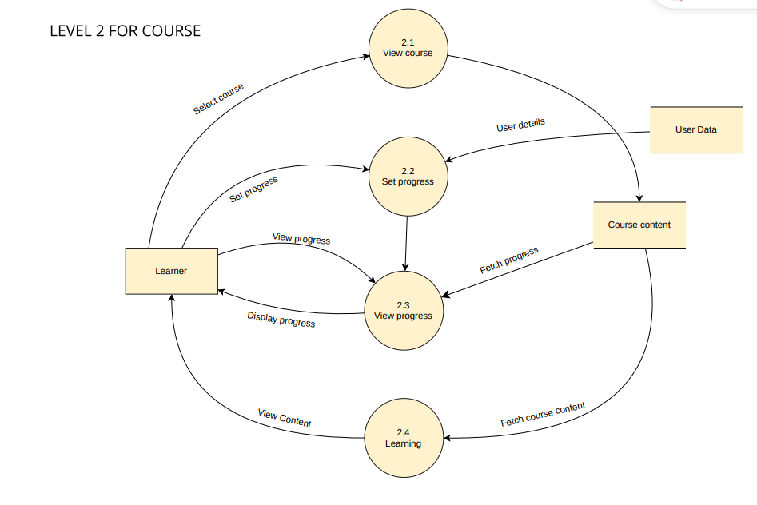

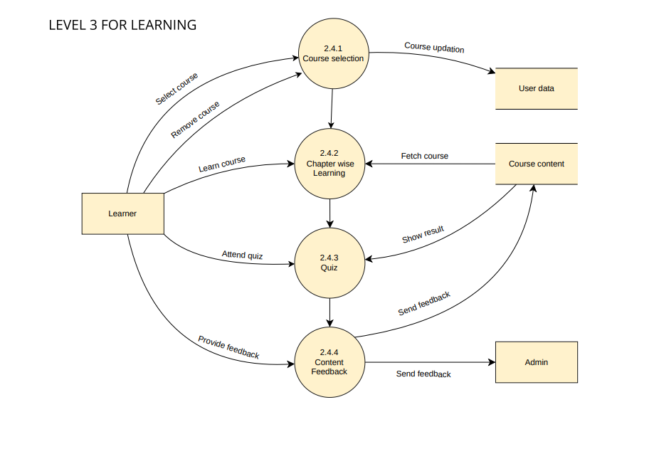

**SEQUENCE DIAGRAM**

REGISTRATION/LOGIN:

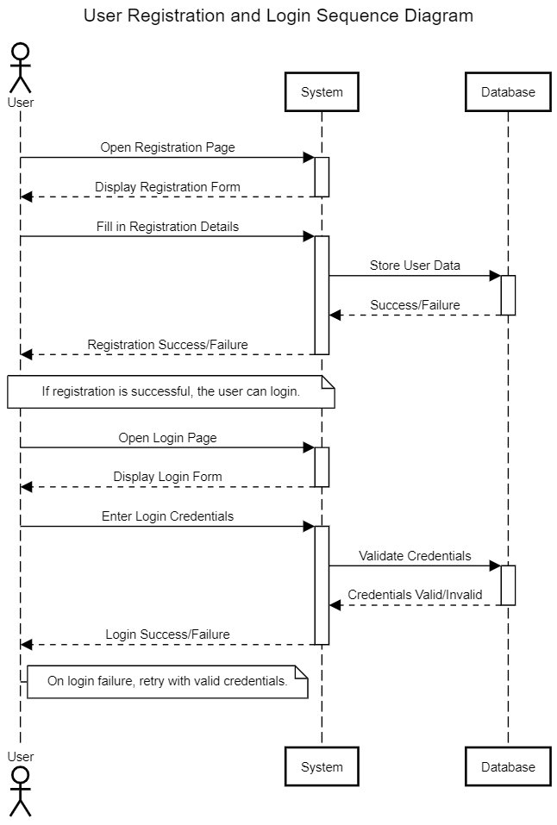

COURSE:

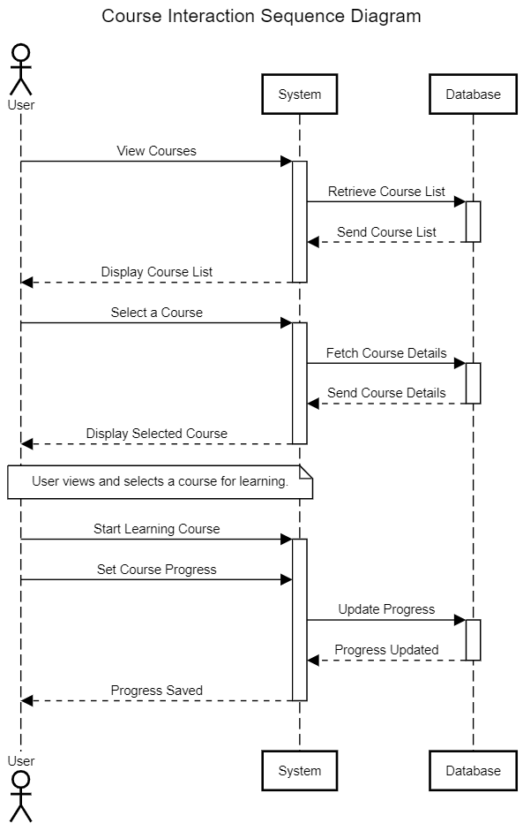

LEARNING:

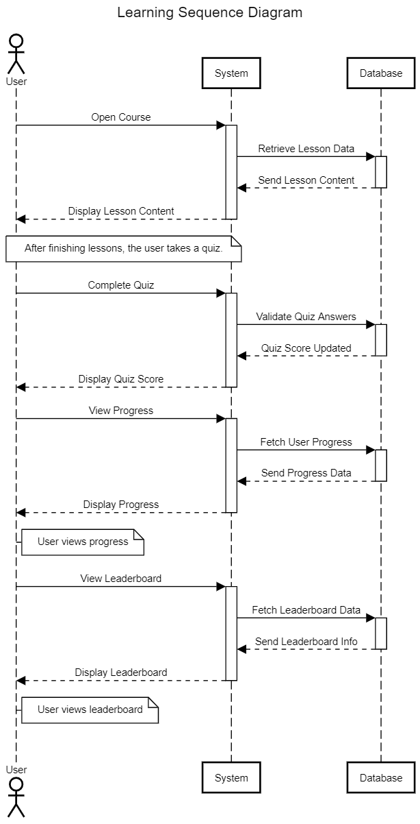

ADMIN:

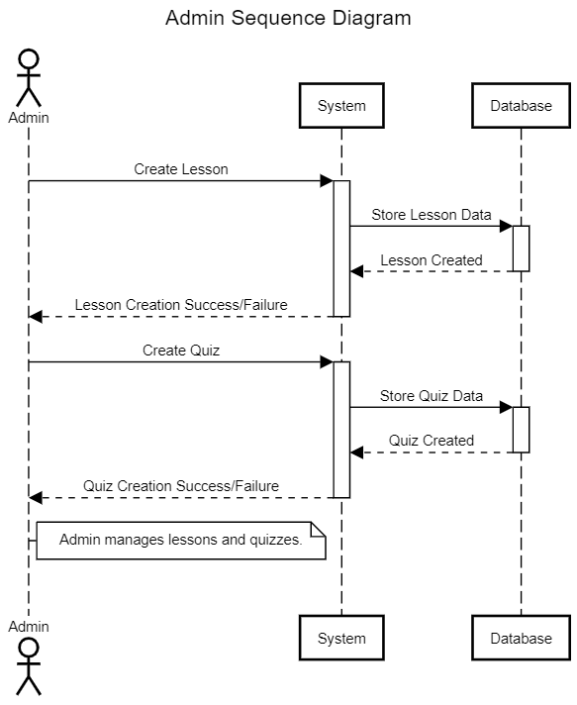

**STATE DIAGRAM**

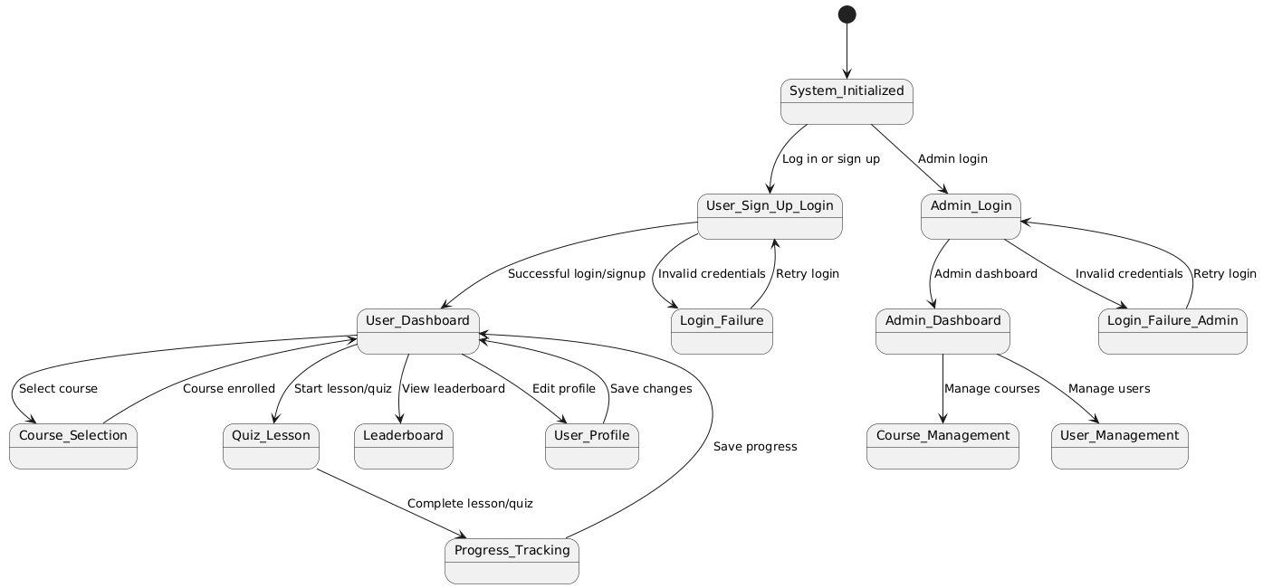

**TESTING**

LoginWindow

import org.junit.jupiter.api.BeforeEach;

import org.junit.jupiter.api.Test;

import static org.junit.jupiter.api.Assertions.*;

import javax.swing.*;

import java.awt.*;

import java.awt.event.ActionEvent;

import java.awt.event.ActionListener;

public class LoginWindowTest {

private JFrame frame;

private JPanel panel;

private JTextField usernameField;

private JPasswordField passwordField;

private JButton loginButton;

private JButton backButton;

@BeforeEach

public void setUp() {

frame = new JFrame();

panel = new JPanel();

usernameField = new JTextField(20);

passwordField = new JPasswordField(20);

loginButton = new JButton("Login");

backButton = new JButton("Back to Profile");

panel.setLayout(new FlowLayout());

panel.add(usernameField);

panel.add(passwordField);

panel.add(loginButton);

panel.add(backButton);

// Adding the panel to the frame

frame.setDefaultCloseOperation(JFrame.*EXIT_ON_CLOSE*);

frame.add(panel);

frame.setSize(400, 300);

frame.setVisible(true);

}

@Test

public void testLoginSuccessful() {

usernameField.setText("user");

passwordField.setText("password");

loginButton.doClick();

try {

Component component = panel.getComponent(2);

*assertTrue*(component instanceof JButton, "Expected a JButton.");

*assertEquals*("Login", loginButton.getText());

} catch (ArrayIndexOutOfBoundsException e) {

*fail*("Component index out of bounds. Check if the components are added correctly.");

}

}

@Test

public void testLoginInvalidCredentials() {

usernameField.setText("wrongUser");

passwordField.setText("wrongPassword");

loginButton.doClick();

JOptionPane.*showMessageDialog*(frame, "Invalid credentials", "Error", JOptionPane.*ERROR_MESSAGE*);

*assertTrue*(true, "Invalid credentials message shown.");

}

@Test

public void testLoginEmptyFields() {

usernameField.setText("");

passwordField.setText("");

loginButton.doClick();

JOptionPane.*showMessageDialog*(frame, "Please enter credentials", "Error", JOptionPane.*ERROR_MESSAGE*);

*assertTrue*(true, "Please enter credentials message shown.");

}

}

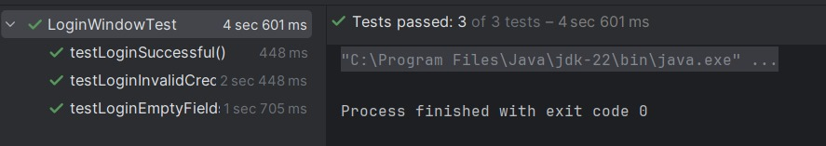

QuizWindow

import org.junit.jupiter.api.BeforeEach;

import org.junit.jupiter.api.Test;

import static org.junit.jupiter.api.Assertions.*;

import javax.swing.*;

class QuizWindowTest {

private QuizWindow quizWindow;

@BeforeEach

void setUp() {

// Initialize the QuizWindow with parameters (title and number of questions)

quizWindow = new QuizWindow("Test Title", 10);

}

@Test

void testQuizWindowInitialization() {

// Ensure that the quizWindow object is initialized properly

*assertNotNull*(quizWindow, "QuizWindow should not be null.");

}

@Test

void testWindowVisibility() {

// Check if the QuizWindow is visible

quizWindow.setVisible(true);

*assertTrue*(quizWindow.isVisible(), "QuizWindow should be visible.");

}

@Test

void testTitleInitialization() {

// Test that the window's title is set to the default one ("Quiz Window")

// We know from the error that it sets the title to "Quiz Window"

*assertEquals*("Quiz Window", quizWindow.getTitle(), "The window title should be 'Quiz Window'.");

}

@Test

void testWindowSize() {

// Check the actual window size, based on the default values set by QuizWindow

*assertEquals*(600, quizWindow.getWidth(), "Width should be 600.");

*assertEquals*(400, quizWindow.getHeight(), "Height should be 400.");

}

// Additional test for questions (placeholder)

@Test

void testNumberOfQuestions() {

// Placeholder test: modify this based on how number of questions affects the UI

*assertTrue*(true, "This test assumes that the number of questions is being used correctly.");

}

}

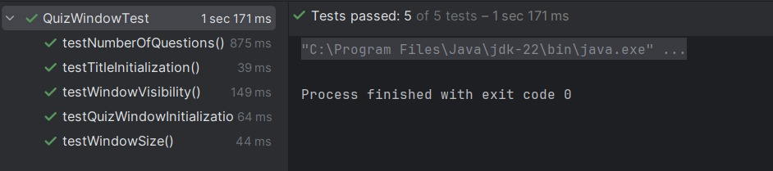

# Traceability Matrix for Interactive Learning Platform

|  |  |  |  |  |  |
| --- | --- | --- | --- | --- | --- |
| **Requirement ID** | **Requirement Description** | **Design Component** | **Implementation** | **Test Cases** | **Status** |
| R1 | User Registration and Login functionality | LoginWindow, RegistrationWindow | Java Swing GUI, Database tables users | TC1: Verify user registration  TC2: Verify login  TC3: Invalid login attempts | Completed |
| R2 | Course selection functionality | CourseSelectionWindow | Java Swing GUI, Database table courses | TC4: Verify course selection, TC5: Verify user-course assignment | Completed |
| R3 | Display and navigate through lessons | LessonWindow | Java Swing GUI, lessons table access | TC6: Verify lesson display  TC7: Verify navigation buttons,  TC8: Lesson completion | Completed |
| R4 | Track user progress and learning streaks | ProfileWindow | Java Swing GUI, Database tables user_progress, learning_streaks | TC9: Verify progress tracking  TC10: Verify streak update logic | Completed |
| R5 | Quiz functionality to assess user knowledge | QuizWindow | Java Swing GUI, Database table quizzes | TC11: Verify quiz display, TC12: Verify user responses, TC13: Verify scoring | Completed |
| R6 | Database connection and utility class for seamless access | DBConnection class | Java utility class for database connections | TC14: Verify connection, TC15: Verify error handling | Completed |
| R7 | User interface with a gradient background | All Windows | Java Swing GUI design | TC16: Verify gradient display  TC17: Verify component visibility | Completed |